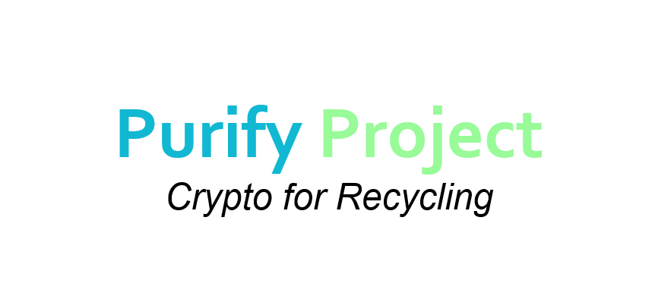

[**https://purifyproject.org**](https://purifyproject.org)

**Technical Paper**

***Michael A.***

**Founder/Lead Dev**

# About us

**The Purify Project was created to revolutionize the way we THINK and ACT about recycling and cleaning in our local communities. Our platform will allow consumers to receive ERC Tokens in exchange for select recyclable materials.**



# What is Recycling

# Recycling is defined as the recovery of materials, such as paper, glass, plastic, metals, construction and demolition (C&D) material and organics from the waste stream (e.g., municipal solid waste), along with the transformation of materials, to make new products and reduce the amount of virgin raw materials needed to meet consumer demands.

**Purify Services**

**Reverse Vending**

Recycle consumer beverage containers fast & easy in select locations.

**Remote Recycling**

Recycle approved items through the mail in a provided box.

**Purify@Home**

Subscription based service for home & office recycling.



***GENERATE A PASSIVE INCOME OFF RECYCLABLES TODAY!!!***

**Reverse Vending**

**What is a RVM**

A reverse vending machine is a device that accepts used (empty) beverage containers and returns money to the user. The machines are popular in places that have mandatory recycling laws or container deposit legislation.

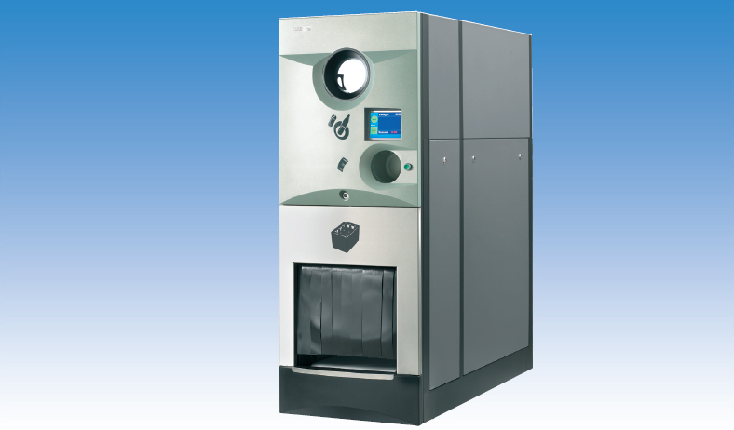

***Courtesy : Anthillonline***

**RVM Payout Rates**

Aluminum

**$0.68/lb\***

PET Plastic

**$0.11/lb\***

HDPE Plastic

**$0.10/lb\***

*Prices subject to market conditions

**Remote Recycling**

We will provide an easy to use mailing service. To use this service users will need to simply submit a form on the website and will receive a box and simply mail back at their convenience.

**Accepted Materials**

Plastic Bottles

Aluminum Cans

Cardboard Paper

**Payout Information**

Upon receiving shipments Purify will verify the contents of your package and issue PURX Tokens based off it’s recyclable value.

**Shipping Info**

We will provide free standard shipping (5-7 Days) on all shipments but users will have the option to upgrade their shipping method for faster payouts.

**Purify@Home**

We are currently designing a home-based recycling service.

Purify will provide members with a specially designed recycling container that can be filled daily and will be picked up after a 30 day period.

Upon container receival we will issue PURX Tokens based off the amount received.

We anticipate releasing a beta program of this service between Q3 - Q4 2018.

**Cost Breakdown**

**Box Subscription Cost**

$10 or equivalent in PURX

**(covers box deposit)**

**Initial Setup Fee**

$5 or equivalent in PURX

(one-time processing fee)

**Purify Funding**

The Purify Project is seeking raise funds to successfully launch our recycling project on the Ethereum Network.

We will be providing a Smart Contract on the Ethereum Network. Users who wish to contribute to our project will need to interact with the Smart Contract using an ERC-20 address.

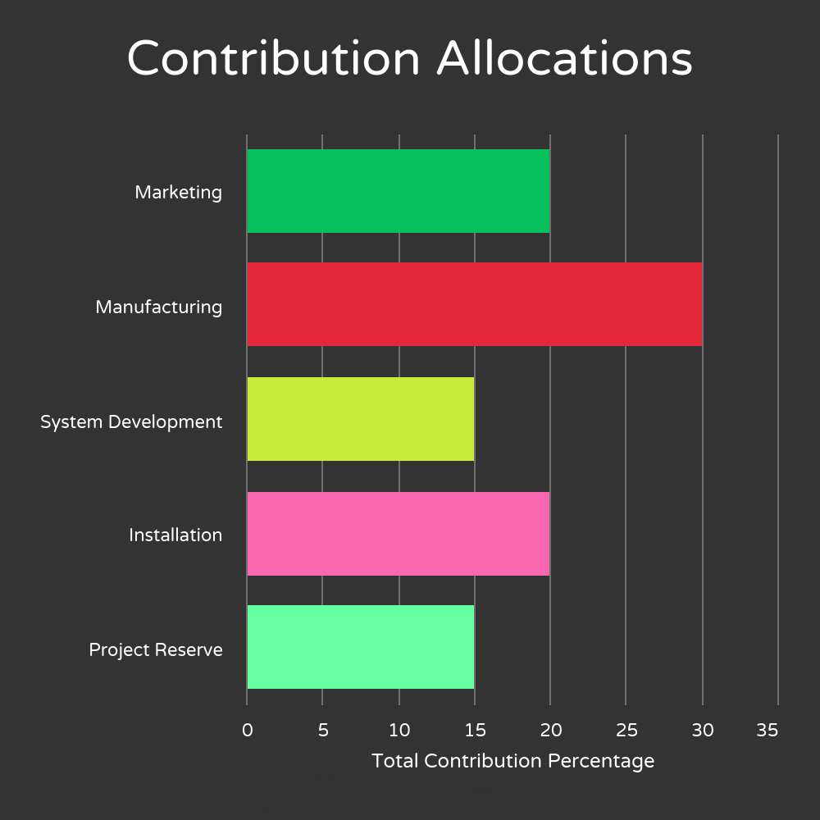

**Purify Funding II**

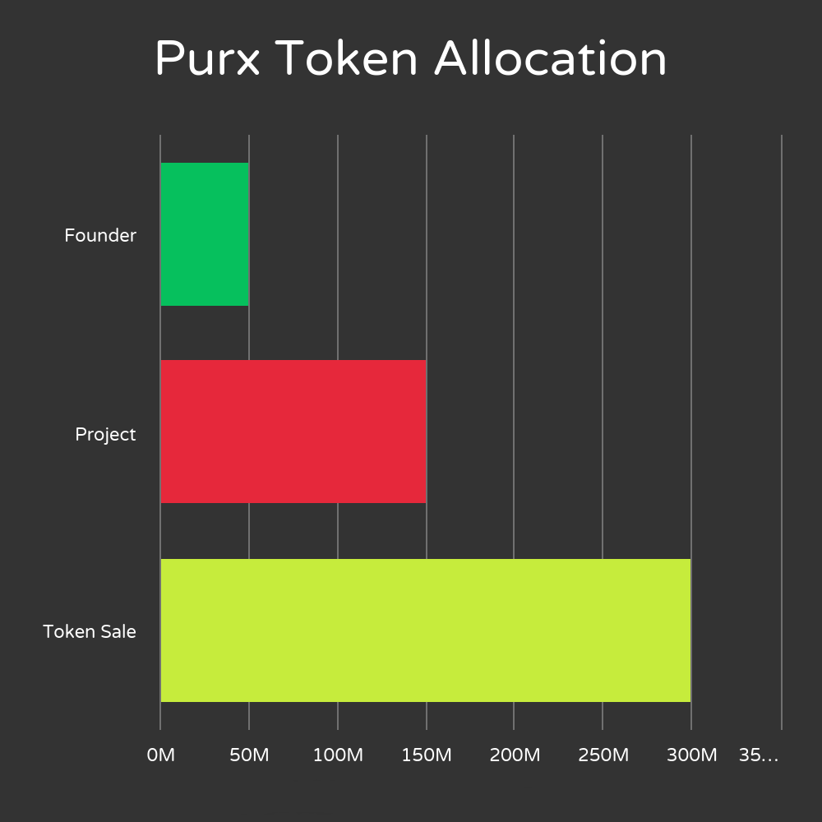

***Join the recycling revolution today***

**Get in Touch**

Website

<https://purifyproject.org>

Email

[hello@purifyproject.org](mailto:hello@purifyproject.org)

Twitter

<https://twitter.com/purifyproject>

Facebook

<https://www.facebook.com/purifyproject>

Reddit

<https://www.reddit.com/user/PURX_DEV/>

LinkedIn

<https://www.linkedin.com/company/purifyproject>



2017 Purify Project | Please Recycle Responsibly | Crypto for Recycling